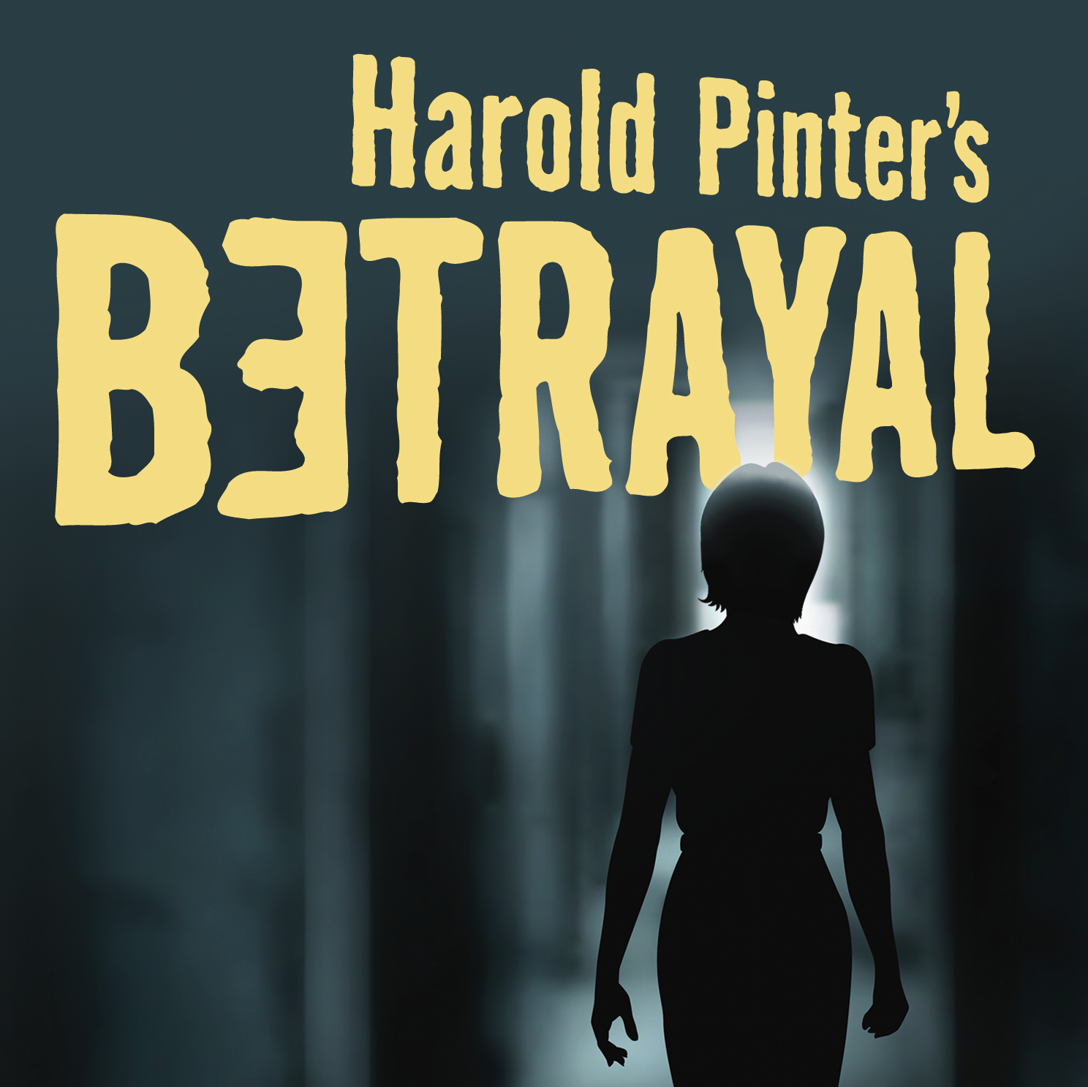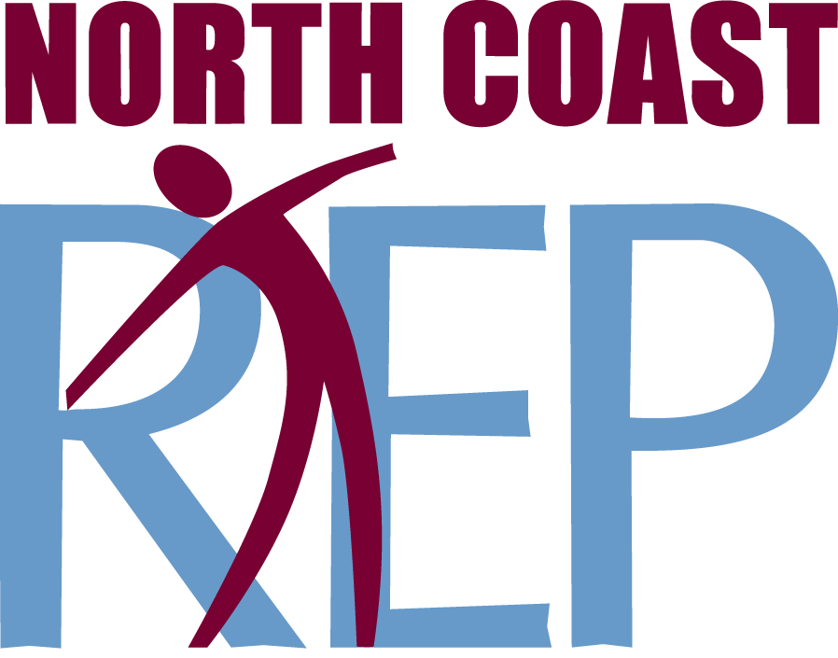
PRESS CONTACT: Nancy Richards – 917-873-6389 (cell)/nancy@northcoastrep.org
MEDIA PAGE: www.northcoastrep.org/press
PHOTOS BY: Aaron Rumley

FOR IMMEDIATE RELEASE, PLEASE:

PASSION, MANIPULATION, DECEPTION
HEAT UP THE STAGE AT NORTH COAST REP
IN HAROLD PINTER’S BETRAYAL
Performances Beginning Wednesday, June 3rd,
With Opening Night, Saturday, June 6th, at 8 pm
Running Through Sunday, June 28, 2015
Directed by Frank Corrado

Master playwright Harold Pinter explores the shifting balance of power within a love triangle. Filled with taut drama and deception, the story unfolds in reverse chronology as the audience takes this this treacherous journey with characters who are compelling and brimming with human frailty. Passionate, explosive and surprisingly funny, BETRAYAL is considered one of Pinter’s most innovative and influential works, one that is certain to provoke lively discussion long after the curtain falls. This is a must-see drama for the discerning theatre-goer.

Director Frank Corrado directs a stellar cast: Richard Baird,* Jeffrey Fracé*, Carla Harting*, and Benjamin Cole. The design staff includes Marty Burnett (Scenic Design), Matt Novotny (Lighting Design), Alina Bokovikova (Costume Design), Melanie Chen (Sound Design), and Benjamin Cole (Props) comprise the crew. Aaron Rumley* stage manages.

BETRAYAL previews begin Wednesday, JUNE 3. Opening Night on Saturday, JUNE 6 at 8pm includes a post-show reception. There will be a special talkback on Friday, JUNE 12, with the cast and artistic director. It will play Wednesdays at 7pm, Thursdays through Saturdays at 8pm, Saturday and Sunday matinees at 2pm with Sundays at 7pm, through June 28, 2015. (See Schedule below.) North Coast Repertory Theatre is located at 987 Lomas Santa Fe Drive, Ste D, Solana Beach, CA 92075. Tickets: Previews- $37; Week Nights - $44; Sat. Eve. & Sun. Mat.- $48; Sat. Mat. & Sun. Night - $41. Seniors, Students, Military - $3 off admission. Call 858-481-1055 or visit www.northcoastrep.org to purchase tickets.

*The actor or stage manager appears through the courtesy of Actors’ Equity Association, the union of professional actors and stage managers in the United States.

For background information and photos, go to www.northcoastrep.org/press.
Please follow North Coast Repertory Theatre on social media
Facebook at https://www.facebook.com/North-Coast-Rep
Twitter: https://twitter.com/NorthCoastRep
YouTube: http://www.youtube.com/user/Northcoastrepvideos

Busy director Frank Corrado and his talented cast are available for interviews by phone, in person, and in- studio. For more information and to arrange interviews or press tickets, please contact Nancy Richards at nancy@northcoastrep.org, or 917-873-6389 cell.

FACT SHEET

WHAT: NORTH COAST REPERTORY THEATRE presents
BETRAYAL
by Harold Pinter
Directed by Frank Corrado

CAST: Richard Baird*, Jeffrey Fracé*, Carla Harting* and Benjamin Cole.

WHERE: North Coast Repertory Theatre
987 Lomas Santa Fe Drive, Ste. D
Solana Beach, CA 92075

SCHEDULE*: Previews: June 3-5, 2015
Opens: June 6, 2015, at 8 pm
Closes: June 28, 2015
Wed. @ 7pm, Thurs-Sat @ 8PM; Sat & Sun @ 2PM, Sun @7pm
Talkback with cast & director: Friday, June 12

PRICES: Previews $37.00
Week Nights $44.00
Sat. Matinees & Sunday Nights $41.00
Sat. Nights & Sunday Matinees $48.00

DISCOUNTS: Seniors, Students, Military $3.00 off admission

BOX OFFICE (858) 481-1055 or www.northcoastrep.org

JUNE
SUN | MON | TUE | WED | THU | FRI | SAT
 |  |  | 3  Preview  8pm | 4  Preview  8pm | 5  Preview  8pm | 6  OPENING  8pm
7  2pm & 7pm | 8 | 9 | 10  7pm | 11  8pm | 12  8pm  Talkback | 13  2pm & 8pm
14  2pm & 7pm | 15 | 16 | 17  7pm | 18  8pm | 19  8pm | 20  2pm & 8pm
21  2pm & 7pm | 22 | 23 | 24  7pm | 25  8pm | 26  8pm | 27  2pm & 8pm
28
2pm & 7pm

BACKGROUND:
North Coast Repertory Theatre’s 2014-2015 -Season 33 concludes with Side By Side With Sondheim (July 15 – August 9). Revel in the sophistication, wit, insight, heart and genius of Broadway’s most innovative and influential artist, composer-lyricist Stephen Sondheim. Audiences will hear familiar favorites from such shows as Company, Follies, A Little Night Music, A Funny Thing Happened on the Way to The Forum, Westside Story, Gypsy and so many more. An unmatched evening of enchantment for musical theatre fans.
Season 34 opens September 9 with The Fox on the Fairway. This hilarious comedy by Ken Ludwig (Lend Me a Tenor, Moon Over Buffalo) scores a hole-in-one with non-stop laughs. The lineup of players includes a beleaguered country club president, his cocky nemesis from a neighboring club, a love-besotted golf pro, his sex-starved vice president, and his suspicious wife. Join us for a wacky evening of fun. Matthew Wiener directs the laugh fest which plays through October 4. Next, Tony Award-winning actress Judith Ivey directs the West Coast premiere of Chapatti by Christian O’Reilly, scheduled for October 21 to November 15. Two lonely animal lovers in Dublin cross paths, and an unexpected spark begins as they re-discover the importance of human companionship. This heartwarming second-chance comedy celebrates unforgettable characters who still believe in love. Sherlock Holmes and the Adventure of the Great Nome Gold Rush, a wildly entertaining adventure kicks off the New Year. David Ellenstein directs the World premiere, which runs January 13 to February 7, 2016. The world’s greatest sleuth, Sherlock Holmes, will stop at nothing to prove a client innocent of murder, even if it means traveling to the Wild West frontier town of Nome, Alaska, and ending up at a bar run by Wyatt Earp. This wild and wooly adventure is full of intrigue, mystery, deception and duplicity. Up next, the West Coast premiere of an outrageously funny farce by the French master George Feydeau, in a brilliant translation by British playwright Kenneth McLeish and directed by Bruce Turk. Now You See It, playing February 24 to March 20, 2016, takes audiences on a dizzying escapade fueled by jealousy bordering on paranoia, a philandering husband, hypnotism, a spurned lover and a scandalous discovery. Furiously fast and clever, this visual and verbal treat is guaranteed to tickle your funny bone. The third West Coast premiere, Way Downriver; William Faulkner’s ‘Old Man’, debuts April 13 to May 8, 2016. David Ellenstein directs. A flood of Biblical proportions on the mighty Mississippi provides the dramatic backdrop to this gripping, edge-of-your seat adventure. Adapted from the William Faulkner short story, “Old Man,” Way Downriver reveals an unlikely pair of souls who are bound together by the forces of nature, and who struggle to overcome their fears and prejudice in order to survive their harrowing experiences. You won’t want to miss this exciting West Coast premiere. Hedda Gabler, arguably one of the most complex and intriguing female characters ever written, will have its debut with a World premiere adaptation created by the company at North Coast Rep, translated by Anne-Charlotte Harvey and directed by David Ellenstein. Hedda Gabler weaves a mesmerizing tale of a woman trapped in a loveless marriage and driven by a need for power and freedom. Discerning theatre lovers will not want to miss this freshly translated classic running from June 1 to June 26, 2016. Season 34 concludes with Ain’t Misbehavin’ playing from July 13 to August 7, 2016 and directed by Obie Award winner Yvette Freeman. Ain’t Misbehavin’ is a roof-raising musical tribute to the black musicians of the ‘20s and ‘30s. Based on the signature Fats Waller song, this rousing musical revue takes audiences back to the glory days of the Harlem Renaissance when the Cotton Club and Savoy Ballroom served as playgrounds for high society. You’ll be tapping your feet as five performers take you on a journey, presenting an evening of rowdy, raunchy, and humorous songs.
About the North Coast Repertory Theatre
North Coast Repertory Theatre is a professional Equity theatre founded in 1982 by Olive and Tom Blakistone. Currently celebrating its 33rd season, North Coast Rep has received critical acclaim from media and audiences alike, and has evolved into one of the area’s leading performing arts organizations. North Coast Rep prides itself on employing the majority of its actors from Actors’ Equity Association for its high quality, award-winning productions, and staging works by established and emerging playwrights. Throughout its history, North Coast Rep has created a platform where artist and audience thrive through the intimacy of live theatre, recognizing the power of theatre to challenge complacency, revitalize the imagination, nurture the unexpected and embrace the variety and diversity in our lives.

BIOS:
HAROLD PINTER (Playwright) was born in London in 1930 and died on Christmas Eve, 2008. He was married to Antonia Fraser. He wrote twenty-nine plays including The Birthday Party, The Caretaker, The Homecoming, and Betrayal, twenty-one screenplays including The Servant, The Go-Between, The French Lieutenant's Woman and Sleuth, and directed twenty-seven theatre productions, including James Joyce's Exiles, David Mamet's Oleanna, seven plays by Simon Gray and many of his own plays including his last, Celebration, paired with his first, The Room at The Almeida Theatre, London in the spring of 2000. In 2005 he received the Nobel Prize for Literature. Other awards include the Companion of Honour for services to Literature, the Legion D’Honneur, the Laurence Olivier Award and the Moliere D'Honneur for lifetime achievement. In 1999 he was made a Companion of Literature by the Royal Society of Literature. He received honorary degrees from eighteen universities.

FRANK CORRADO (Director) has worked in the theatre as actor, playwright, director, producer and curator for forty years. He has performed leading and character roles in all the major theatres in Seattle, where he has lived since 1981, and at many of the most highly regarded regional venues across the country, including in NCR’s productions of Madagascar, The Drawer Boy and Harold Pinter’s The Dumb Waiter. In March 2009, shortly after the playwright’s death, he launched the popular play-reading series “Pinter Fortnightly” at Seattle’s ACT Theatre which over the course of three years presented staged readings of all of the Pinter ‘canon.’ The success of the series led in 2012 to a festival devoted to full productions of the plays No Man’s Land, Old Times, Celebration and The Dumb Waiter, as well as many of the playwright’s revue sketches, and public screenings of a number of the films which Pinter wrote. In 2010, Mr. Corrado was awarded the Fox Foundation Fellowship for Distinguished Achievement, partly in recognition and in support of his adventures in Pinterland. Mr. Corrado is a proud member of Actors’ Equity Association.

RICHARD BAIRD* (Robert) is pleased to return to North Coast Rep where he has appeared in School for Lies, Ghosts, Dumb Waiter/The Lover, Rashomon, Arcadia and many more. Richard is the founding Artistic Director of New Fortune Theatre Company which premiered with Henry V. (SD Critics Circle Award for Best Actor and Co Director) elsewhere: Romeo and Juliet (Arizona Theatre Company); The Dolls House (Old Globe); A Midsummer Nights Dream (Portland Center Stage); Madness of King George and Cyrano De Bergerac (Chicago Shakespeare); the title role of Macbeth and Leontes in Winters Tale at Kingsmen Shakespeare; Southwest Shakespeare Company; Oregon Shakespeare Festival; Shakespeare Santa Cruz and many more. Richard is a proud member of Actors Equity.

JEFFREY FRACÉ *(Jerry) has appeared as an actor in more than 70 professional productions internationally. He is a former Associate Artist of Anne Bogart’s SITI Company, performing with the company for over 10 years. Recent credits include Rapture, Blister, Burn; Celebration and Old Times (Pinter Festival); and Lieutenant of Inishmore, all at ACT Theatre in Seattle. Other credits include the Kennedy Center, New York Shakespeare Festival, American Repertory Theatre, Actors Theatre of Louisville, Alabama Shakespeare Festival, Nashville Shakespeare Festival, Stonington Opera House, Cleveland Public Theatre, Chopin Theatre Chicago, and La MaMa. His directing credits span opera, theatre, and dance; and his original work has been presented in New York, Seattle, Nashville, Cleveland, Boston, and Maine. He is a founding member of the award-winning ensemble Conni's Avant Garde Restaurant, writing for and performing in their original shows in New York and nationally. Next, Jeffrey will direct Merry Wives of Windsor at Stonington Opera House, and his latest devised work The Life Model will premiere at On the Boards in January 2016. Jeffrey lives in Seattle and teaches acting, movement, and devising theatre at University of Washington. MFA, Columbia University.

CARLA HARTING* (Emma) is happy to return to North Coast Rep, having last appeared as Becky in Becky’s New Car. She most recently played May in Fool For Love at Cygnet and Ivy in August: Osage County at The Old Globe. Her New York credits include the premieres of Sarah Ruhl’s Dead Man’s Cell Phone at Playwrights Horizons and Eurydice at Second Stage. Carla has worked on numerous other new plays in New York such as Jimmy Carter Was a Democrat, Freakshow, and Late: A Cowboy Song with Clubbed Thumb, Kid-Simple in the Summer Play Festival, and Be Aggressive at Soho Rep. She has had the honor of participating in numerous Humana Festivals at ATL, working with such playwrights as Naomi Iizuka, Gina Gionfriddo, Jordan Harrison, and Theresa Rebeck. Carla has performed at Arena Stage, Seattle Rep, Yale Rep, The Wilma, South Coast Rep, San Diego Rep, La Jolla Playhouse, and The Studio Theatre, DC. Her film and television credits include Never Forever with Vera Farmiga, “Law & Order” and “Law & Order: CI.” Carla received her MFA from UCSD.

BENJAMIN COLE (Waiter) is proud to be Artistic Associate for North Coast Repertory Theatre. Recent local acting credits include: Faded Glory, Who Am I This Time?, (North Coast Repertory Theatre); The Christmas Toyshop, You’re A Good Man, Charlie Brown, Sleeping Beauty, A Year With Frog and Toad (North Coast Repertory Theatre PTF); Ether Dome, (La Jolla Playhouse); The Lion in Winter (Moonlight Stage Productions); The Foreigner (Lamb’s Players Theatre); A Midsummer Night’s Dream (Intrepid Shakespeare); Punk Rock, The Mystery Plays (ion theatre); Coming Attractions (Moxie Theatre); Holiday Spirits, Almost, Maine (Scripps Ranch Theatre). Other theatre nationally: Orlando Shakespeare Theater, Oklahoma Shakespearean Festival, Illinois Shakespeare Festival, Pigeon Creek Shakespeare Company, and Clinton Area Showboat Theatre. Ben also directs and acts in readings for NCRT, and teaches and directs for the Theatre School at NCRT. Education: MFA in Acting from WIU, BFA in Acting/Directing from CMU, Ireland study abroad from NYU.

AARON RUMLEY* (Stage Manager) North Coast Repertory Theatre: Unnecessary Farce, Gunmetal Blues,Fallen Angels, Who Am I This Time?, Broken Glass, Two by Pinter: The Lover andthe Dumb Waiter, THIS, The Lion in Winter, Heroes, Lend Me a Tenor, My Name is AsherLev, The Drawer Boy, Becky’s New Car, Voice of the Prairie, Ghosts, Glorious!, Talley’s Folly, Over the Tavern, Rabbit Hole, The Dresser, Don’t Dress for Dinner, Madagascar,
Mornings at Seven, String of Pearls, Dracula, Rashomon, Wit, A Moon for the Misbegotten, Leading Ladies, Collected Stories, Halpern & Johnson, Romeo and Juliet, The Bungler, The Chosen, A Life in the Theatre and The Rainmaker. North Carolina Theatre: Talley’s Folly, Picnic, The Miser and On Golden Pond. Aaron received a B.A. in Theatre from the University of North Carolina at Wilmington, and is the production manager at the
North Coast Repertory Theatre. Aaron is a Member of Actors’ Equity Association.

DESIGN TEAM

MARTY BURNETT (Resident Scenic Designer) Marty begins his 23rd season as Resident Designer/Technical Director at North Coast Rep. He has designed the last 167 shows. Other venues include Laguna Playhouse, Portland Stage Company, Drury Lane (Chicago), Claridge Hotel (Atlantic City), Union Plaza, Sahara Hotel, Hacienda in Las Vegas, Coronado Playhouse, Scripps Ranch Theater, Harrah’s Lake Tahoe. Marty is a proud alumni of Creighton University in Omaha, Nebraska.

MATT NOVOTNY (Lighting Design) recently designed the lighting for Unnecessary Farce, Gunmetal Blues, Freud’s Last Session, Fallen Angels, Romance Romance, Faded Glory, Mandate Memories, The School For Lies, Who Am I This Time?, Broken Glass, Man with a Load of Mischief, Perfect Wedding, Becoming Cuba, The Odd Couple, Time Stands Still, Educating Rita, The Underpants, Dames at Sea, Two by Pinter: The Lover and The Dumb Waiter, THIS, Visiting Mister Green, Lend Me a Tenor, Five Course Love, My Name Is Asher Lev, King O’ the Moon, Ghosts, Glorious, I Love You Because, Old Wicked Songs, Rabbit Hole, Shipwrecked!, The Dresser, Don’t Dress for Dinner, Mornings at Seven, Baby and Rashomon at North Coast Rep. He was the Director of Production for Lyric Opera San Diego. Lighting designs include: Iolanthe, The Merry Widow, The King and I, Countess Maritza, and The Mikado. San Diego: Das Barbecu, The Wiz, West Side Story and Rumors. Regional: Yankee Doodle Dandy (Seattle), Noises Off! (Boston), The Game, (Washington D.C.) and Primal Twang, a guitar concert featuring six Grammy-winning artists. Matthew holds a B.A. in Technical Theatre from San Diego State University, and an M.F.A. from Boston University.

ALINA BOKOVIKOVA (Costume Design) has designed more than 50 different productions and is proud to be a resident designer at North Coast Repertory Theatre. Her recent credits include Unnecessary Force, Chapter Two, Gunmetal Blues, Freud's Last Session, Fallen Angels, School for Lies, Romance, Romance, Words By, Broken Glass. Other favorite works are Bird Lady (Link Theatre, Chicago) A Doll's House (The Old Globe Theatre), A Raisin in the Sun (MOXIE Theatre), Camino Real (Patté Award), opera La Traviata. Ms. Bokovikova has an M.F.A. in Costume Design from UC San Diego and a Masters Degree in Education from Russia. She is teaching at UC San Diego, Fashion Institute of Design & Merchandising and Grossmont College.

MELANIE CHEN (Sound Design) is thrilled to be working with North Coast Rep again! She is a San Diego based freelance sound designer who has designed over 50 productions in San Diego, Los Angeles, and San Francisco. Select San Diego credits include: Plays by Young Writers Festival 2015 with Playwrights Project, Pericles: Prince of Tyre with the USD MFA Program, Summer Shakespeare Intensive 2014 (The Old Globe); A Streetcar Named Desire (University of San Diego); Unnecessary Farce, Freud’s Last Session (North Coast Rep); Passion, Bug, Bengal Tiger at the Baghdad Zoo, Blasted (Craig Noel Nomination), Angels in America (Craig Noel Award for Outstanding Sound Design) (ion theatre company); Baby with the Bathwater (Diversionary Theatre); Crumbs from the Table of Joy (Craig Noel Nomination) (Moxie Theatre). Also check out her work on The Whale at Cygnet Theatre in Old Town San Diego and Sylvia at New Village Arts in Carlsbad. Coming up, Melanie will be working with the La Jolla Playhouse and San Diego Museum of Man on their site-specific theatre piece about immigration, Border Crossing. Later this summer, she will be assisting Tony Award nominated designer Sten Severson on The Old Globe’s 2015 Summer Shakespeare Festival on the Lowell Davies Festival Theatre stage. Melanie holds an M.F.A. in Sound Design for Theatre & Dance from UC San Diego. For more info, visit her website at www.melaniesound.com.

BENJAMIN COLE (Properties Designer/Set Dressing), is proud to be part of the North Coast Rep family as Artistic Associate. Additional Properties Designs/Set Dressing at North Coast Rep include: Unnecessary Farce, Chapter Two, Gunmetal Blues, This Wonderful Life, Freud’s Last Session, Fallen Angels, Romance/Romance, Faded Glory, Mandate Memories.

JOHN FINKBINER (Scenic Artist) John has been a member of the North Coast Repertory Theatre staff for more than six years. His favorite shows are Halpern and Johnson, SHIPWRECKED!, The Dresser and Jacques Brel. John received his BA degree at UCLA’s School of Theater, Film and Television in 1991. John is also an accomplished singer/songwriter and performs with his band, the Stereotypes. His music has been featured on Showtime’s “Californication,” Fox’s “Bones” and NBC’s “Knight Rider,” among others. John lives with his wife Judi and his son John Gibson in Leucadia.

# # #

